## The problem

In May 1994, in the development phase of the Typhoon Eurofighter, BAe Systems wanted to ensure that the canopy release mechanism of the planned fighter jet would work under all conditions without fail.

The company agreed to test Lofrix® Dry friction inhibiting product with a view to using the anti-friction agent in the Eurofighter cockpit, with the proviso that it was a pre-requisite that it would perform to specification under all flying condition, including extremes of temperature and hostile environments – such as high moisture and salt spray.

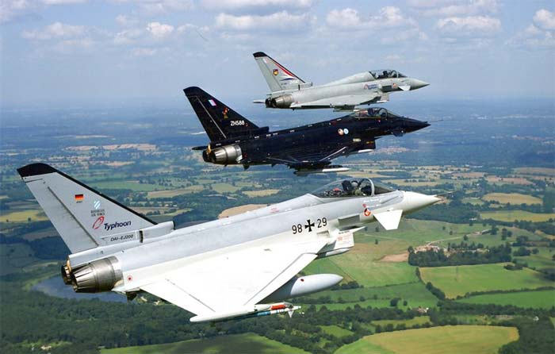

## The result

The Lofrix® Dry friction inhibitor passed all tests and was subsequently authorized to be the only product permitted for use on the Typhoon canopy release mechanism.

The data held from the results of the tests is confidential to British Aerospace and subject to the provisions of the Official Secrets Act. However, all the tests showed significantly better than predicted results with the co-efficient of friction tests showing a dramatic improvement over expected results.

British Aerospace has been successfully using Lofrix® Dry for this application for around 20 years, and Lofrix has been awarded a permanent authority to supply.

## The solution

A stringent test programme for Lofrix® Dry was established and five years of testing and trials took place by British Aerospace before approval was granted for the product to be used in the construction and operation of the fighter aircraft.

A range of tests, including comparative tests, were undertaken over a five year period that covered volumetric wear, corrosion (salt spray test – BS 7479) and co-efficient of friction. These tests were undertaken on different metals in a variety of environments (including extreme heat and cold) and repeated thousands of times without a single failure being recorded.

*Typhoon Eurofighter*